FIS WORLD CUP-ROLLERSKI TOUR 2001

VALLOIRE - GALIBIER - FRANCE

August 3-4-5 Août 2001

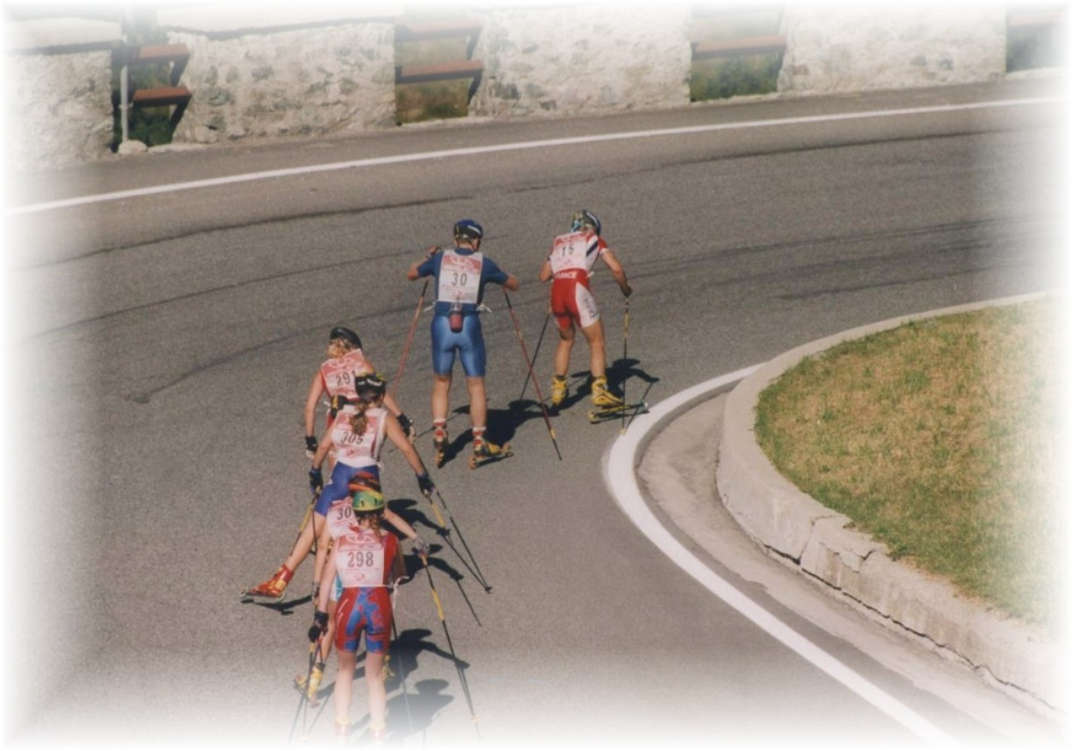
- ENTRIES (Country) : Before JULY 1, 2000

valloire@rollerskitour.com
tel : + 33 6 60 88 40 42
fax : +33 4 77 33 84 78


FIS WORLD CUP-ROLLERSKI TOUR 2001 FRANCE
INVITATION VALLOIRE August 3-4-5 2001

- ORGANISATION FRENCH SKI FEDERATION
- PLACE VALLOIRE GALIBIER
- COMPETITION MANAGER Jean Pierre COCHET
- ENTRIES: Before JULY 1, 2001

FEDERATION FRANCAISE DE SKI
Jean Pierre Cochet
145, rue de la Montat
F-42100 SAINT ETIENNE

TEL. + 33 4 77 33 77 64
FAX. +33 4 77 33 84 78 valloire@rollerskitour.com

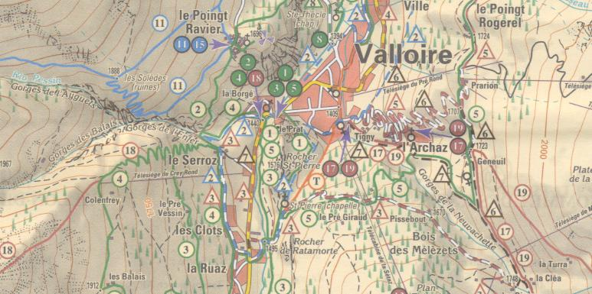
Teams will be welcome at the 3rd leg of the FIS Rollerski World Cup – Rollerski Tour 2000 in Valloire Galibier French Alps.

We are waiting you at the “Offfice du Tourisme” in Valloire, on Thursday August 2, 2001 from 8 a.m. until 8 p.m. If you arrive before, contact us for agreements for hotels.

At this moment every national team has to pay the expenses for board and lodging.

Jean Pierre Cochet

Programme :

Thursday 02 08 2001 – Team arrival - 21H00 Opening ceremony

Friday 03 08 2001 - 17H00- WC Uphill track (Galibier) 10km free style. –21H00 Prize ceremony with bibs presentation to the top 10, men and women.

Saturday 04 08 2001 -14H00 Prologue 200m start every 15 sec free style – 15H30- 17H00- K.O sprint event in the ski resort of Valloire. Prize ceremony with World Cup and VIP party.

Sunday 05 08 2001 – Delegations departure

MONEY PRIZES 4500 €

More information

WORLD CUP - VALLOIRE - ENTRY FORM

LATEST ENTRY DATE: JULY 20, 2001

Nation:

Official Responsible:

Number of competitors:
(Please add the list of the competitors)

Number of officials no competitors:

Team total number:

Date and time of arrival:

Signature and name responsible Official:

BIENVENUE, WELCOME BENVENUTO BIENVENIDO TERVETULOA WILLKOMMEN VÄLKOMMEN

